# Class Imbalance graph

* ADASYN

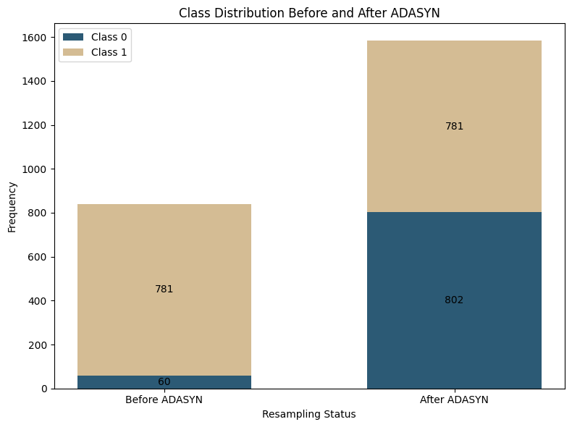

* SMOTE

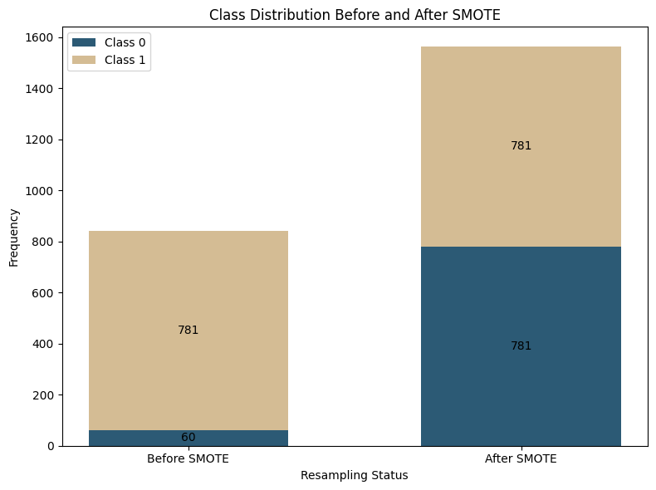

* Near Miss (make train data smaller than test data (120 vs 400)

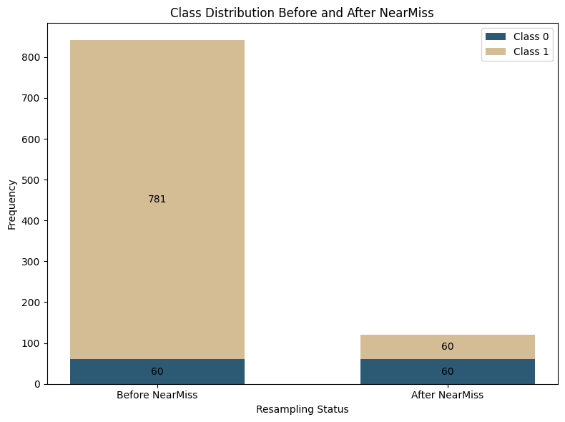

* OSS (failed at it because it is still imbalanced. This is due to OSS nature)

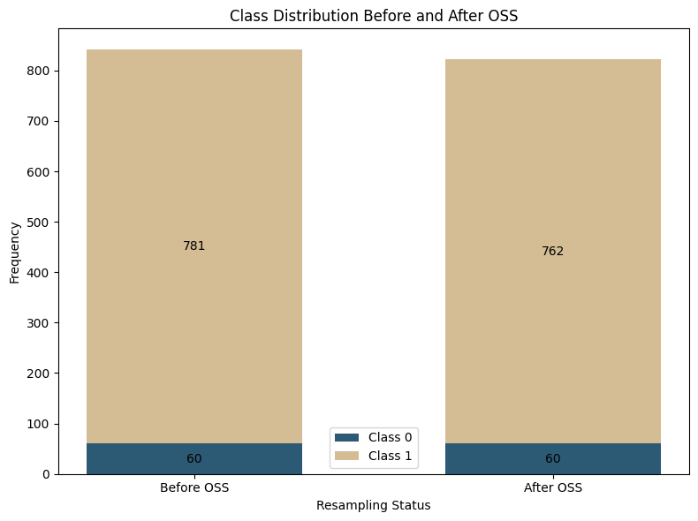

# Baseline

* ADASYN (left: validation, right: test)

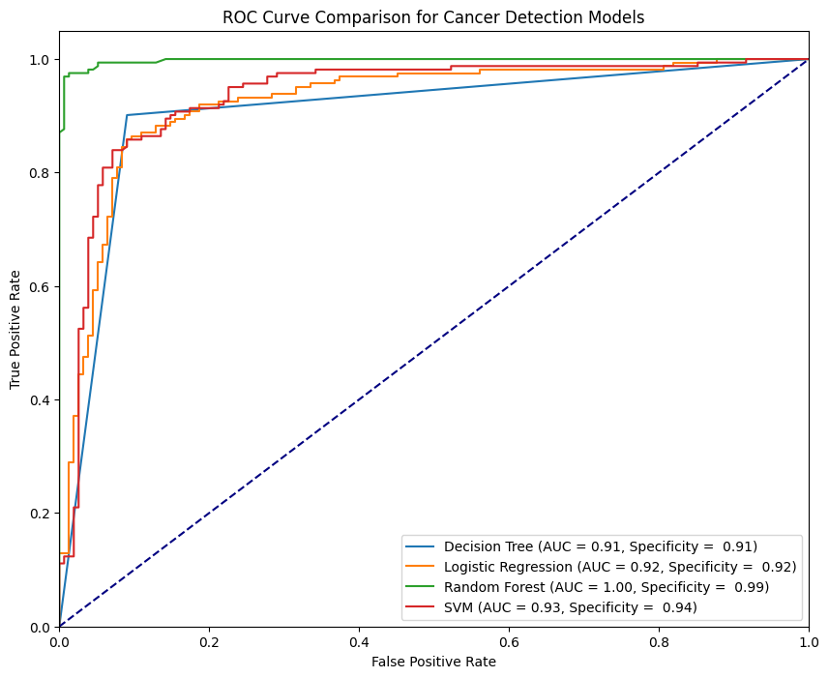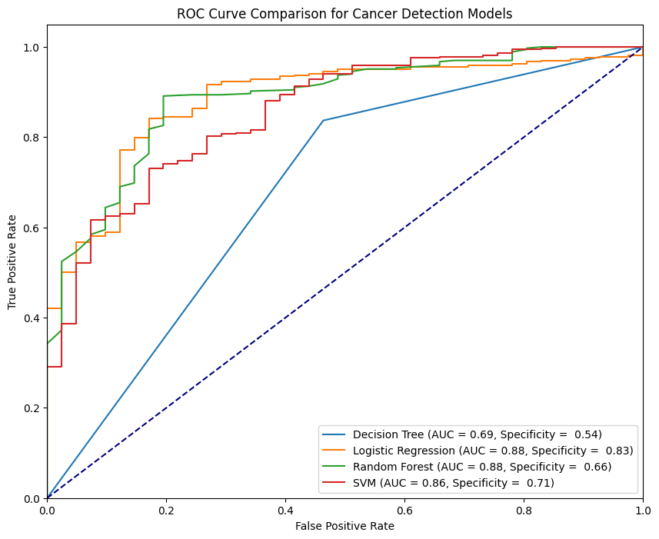

* SMOTE (left: validation, right: test)

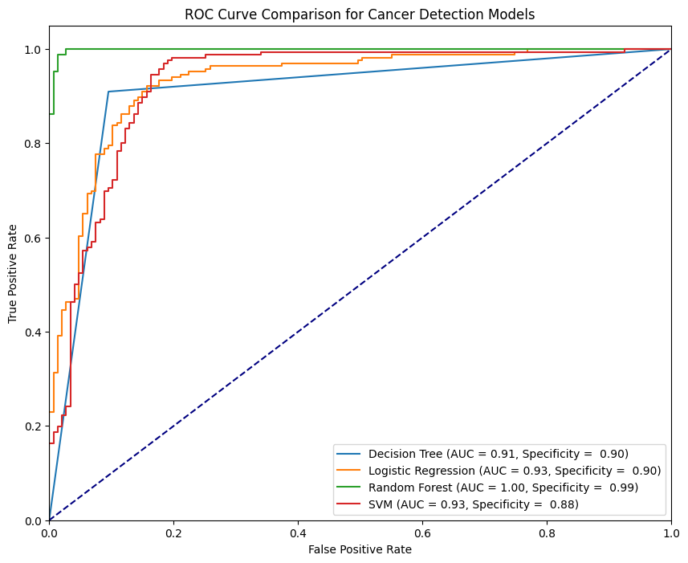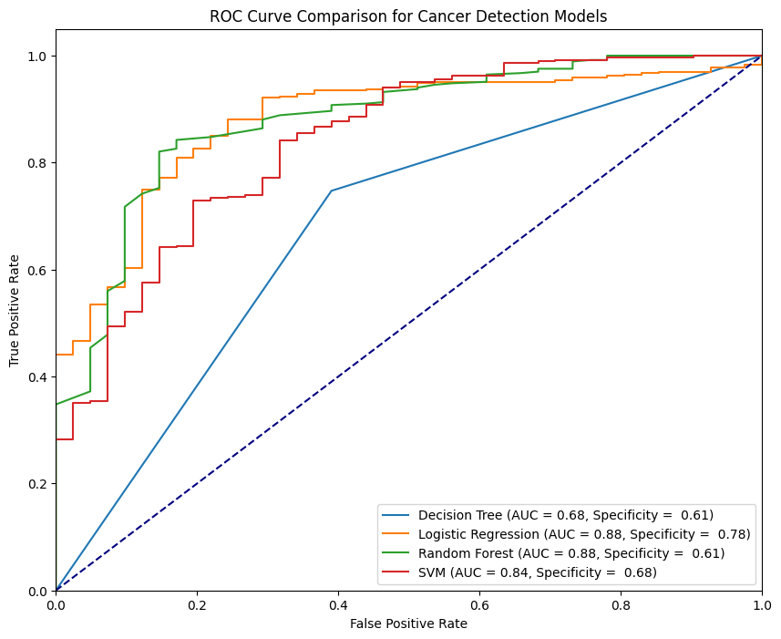

Sign of overfitting: test against validation data is high but when against the test data is quite low (especially random forest).

# Hyperparameters tuning

* ADASYN

1. DT

-> best parameter: {'dt__class_weight': 'balanced', 'dt__criterion': 'entropy', 'dt__max_depth': 10, 'dt__max_features': None, 'dt__min_samples_leaf': 1, 'dt__min_samples_split': 10}

-> specificity against validation data using the best parameter: 0.68

1. LR

-> best parameter:{'lr__C': 1, 'lr__penalty': 'l1', 'lr__solver': 'liblinear'}

-> specificity against validation data using the best parameter: 0.92

1. RF

-> best parameter: {'rf__bootstrap': True, 'rf__max_depth': 2, 'rf__max_features': 0.75, 'rf__min_samples_leaf': 5, 'rf__min_samples_split': 15, 'rf__n_estimators': 150}

-> specificity against validation data using the best parameter: 0.78

Test against the test data using the best parameters:

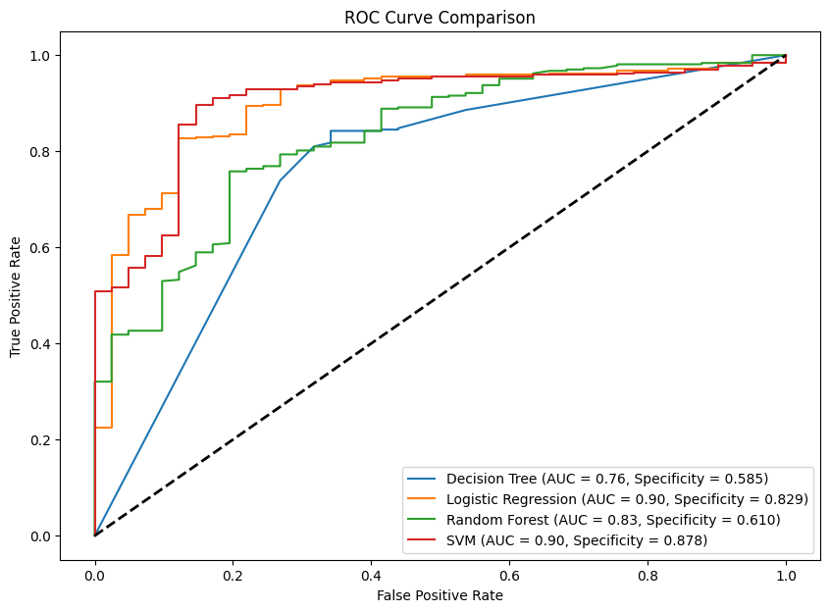

Best: SVM (0.88)

* SMOTE

1. DT

-> best parameter: {'dt__class_weight': 'balanced', 'dt__criterion': 'gini', 'dt__max_depth': 20, 'dt__max_features': None, 'dt__min_samples_leaf': 5, 'dt__min_samples_split': 10}

-> specificity against validation data using the best parameter: 0.67

1. LR

-> best parameter: {'lr__C': 1, 'lr__penalty': 'l1', 'lr__solver': 'liblinear'}

-> specificity against validation data using the best parameter: 0.88

1. RF

-> best parameter: {'rf__bootstrap': True, 'rf__max_depth': 2, 'rf__max_features': 0.75, 'rf__min_samples_leaf': 5, 'rf__min_samples_split': 15, 'rf__n_estimators': 150}

-> specificity against validation data using the best parameter: 0.77

1. SVM

-> best parameter:{'C': 1, 'kernel': 'linear'}

-> specificity against validation data using the best parameter: 0.85

Test against the test data using the best parameters:

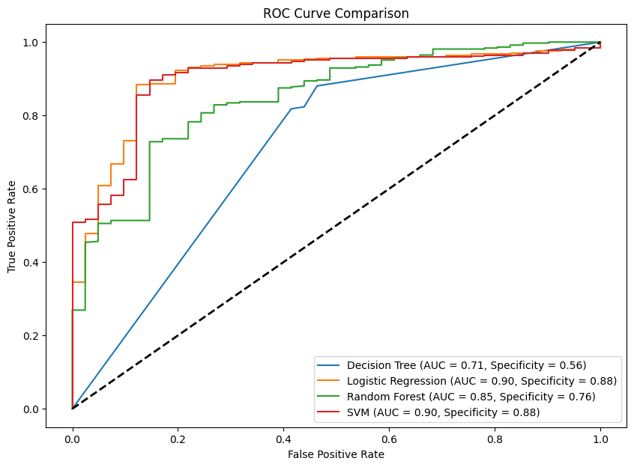

Best: Logistic Regression + SVM (0.878)